User Flow
How each user works through the system, by role. The order of the work is in Flow Chart; the pages are in Site Map.

Roles
Role | Department | Who | First page
Admin | any (only a label) | Owner / office: does everything | Dashboard: order tiles, invoice tiles, chart
Worker | Sales | Sale Worker: quotations (a production order is only read) | Dashboard: order tiles
Worker | Factory | Factory Worker: the processes, production, stock, purchase | Dashboard: order tiles

A Worker must have the department Sales or Factory; the department decides what the Worker can do. There is no sign-up and no forgot-password: an Admin makes the accounts and sets the passwords.

Everyone: sign in and move around
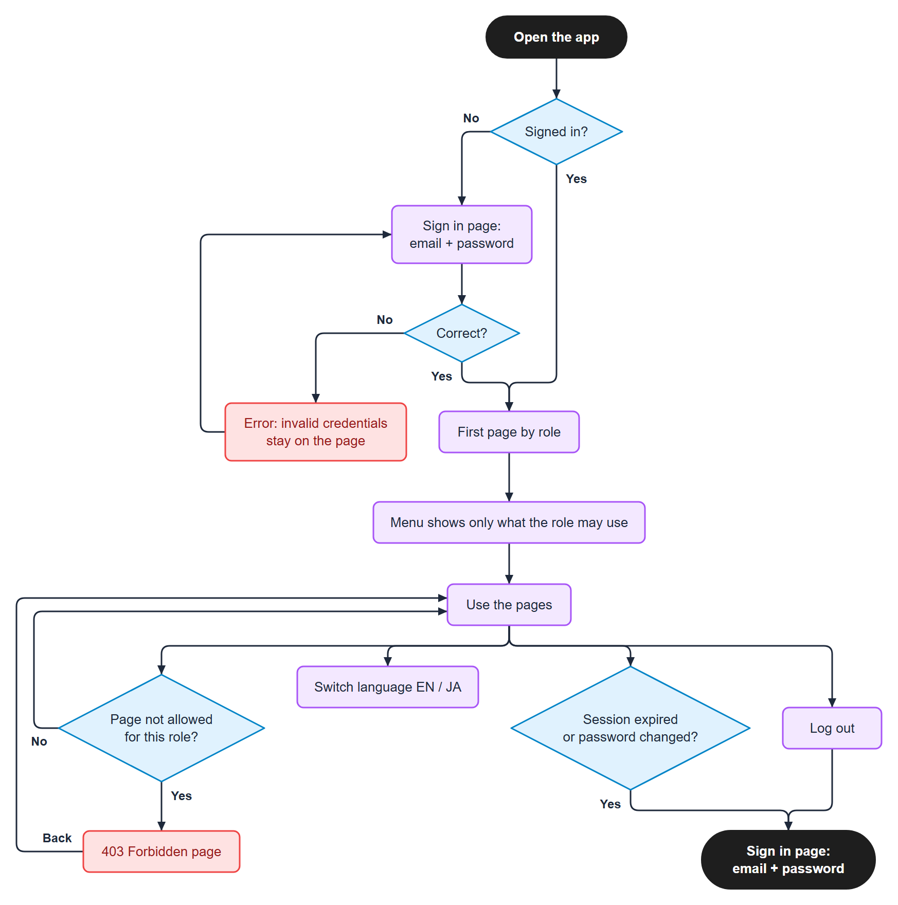
Figure 1. Everyone: sign in and move around
- The menu hides what the user may not use; the backend checks the same rules on every call.
- A menu that has only one visible entry is shown as that entry alone.
- An unknown address opens the Not found page; old addresses of moved pages are redirected.

Sale Worker

Pages
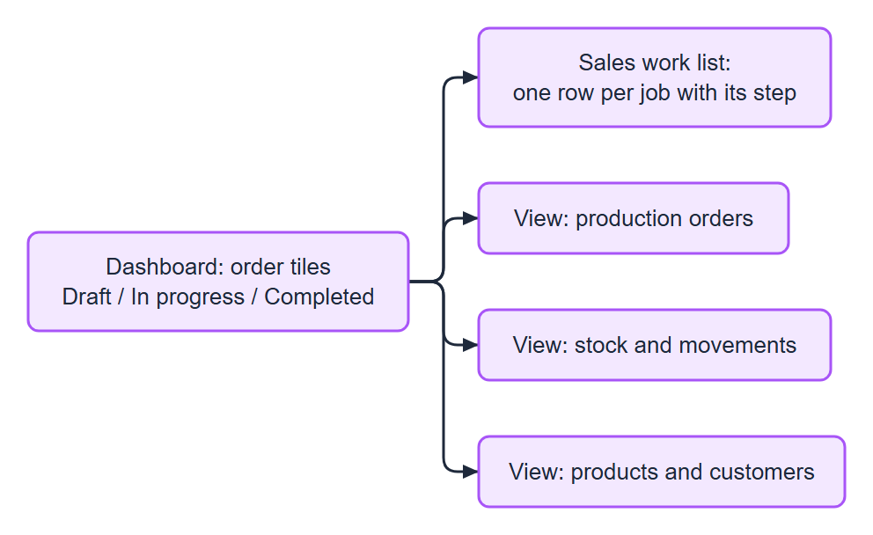
Figure 2. Pages

Make and confirm a QT
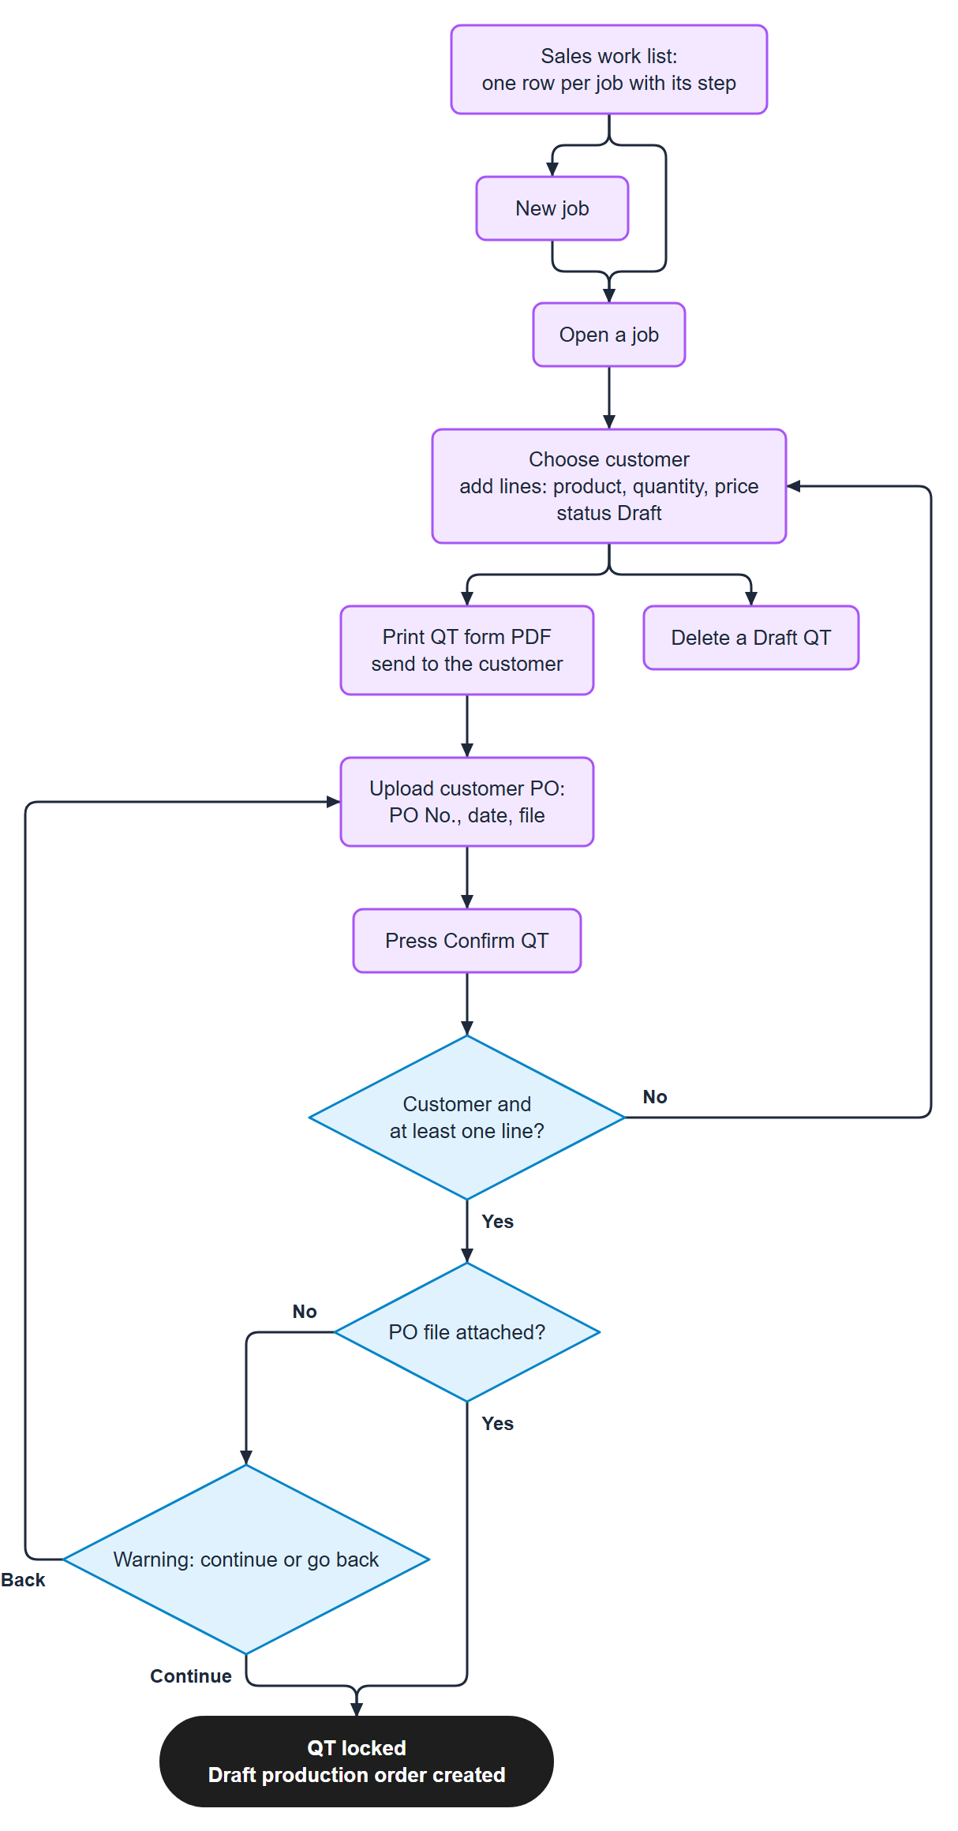
Figure 3. Make and confirm a QT

After Confirm
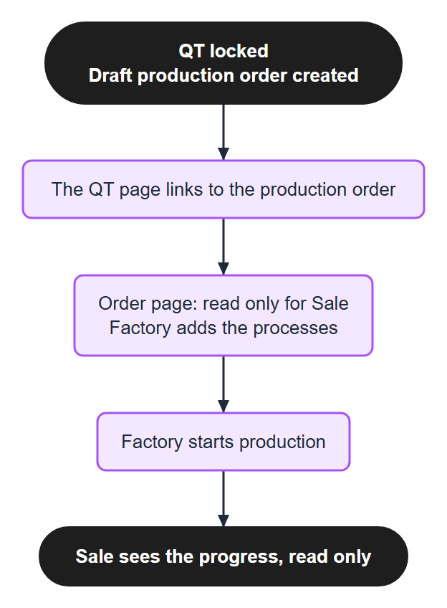
Figure 4. After Confirm
What the Sale Worker cannot do: add or change the processes of an order, start production, record progress, change stock, open Purchase, Accounting, Suppliers or Users. A confirmed QT is locked and cannot be deleted; an order cannot be made by hand, only by Confirm QT.

Factory Worker

Prepare and start an order
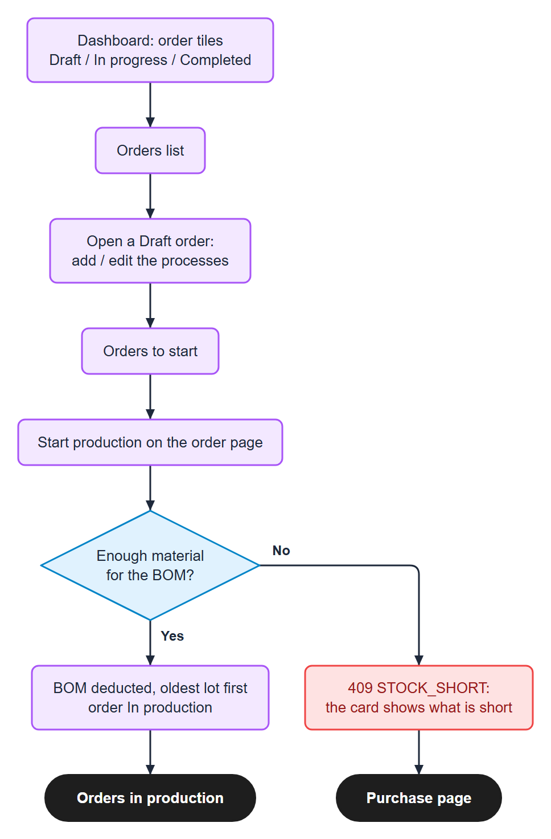
Figure 5. Prepare and start an order

Record progress
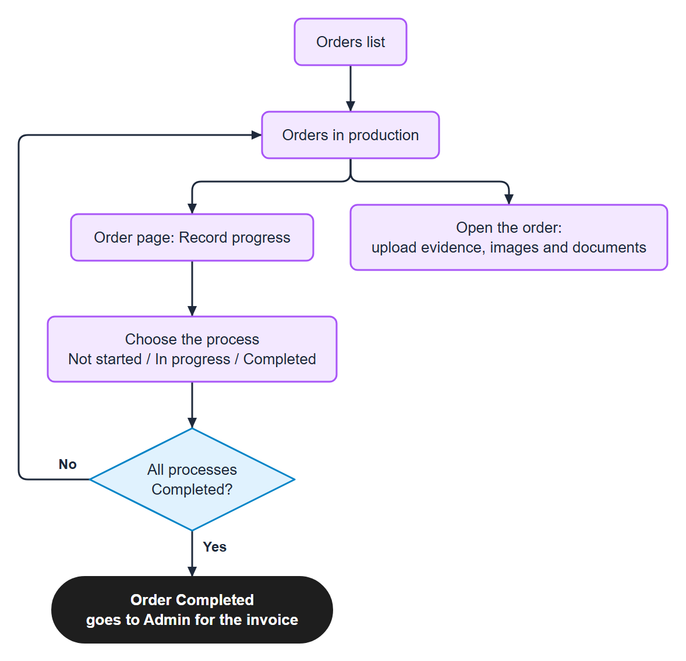
Figure 6. Record progress

Purchase and stock
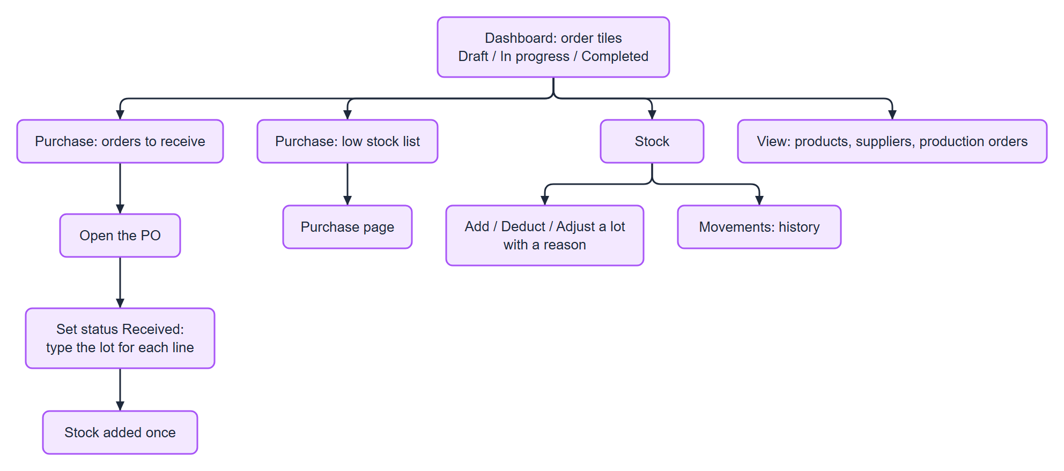
Figure 7. Purchase and stock
A Factory Worker cannot reopen a Completed process (Admin only), cannot change QT, customers, products or materials, and cannot open Accounting or Users.

Purchase (Factory Worker and Admin)
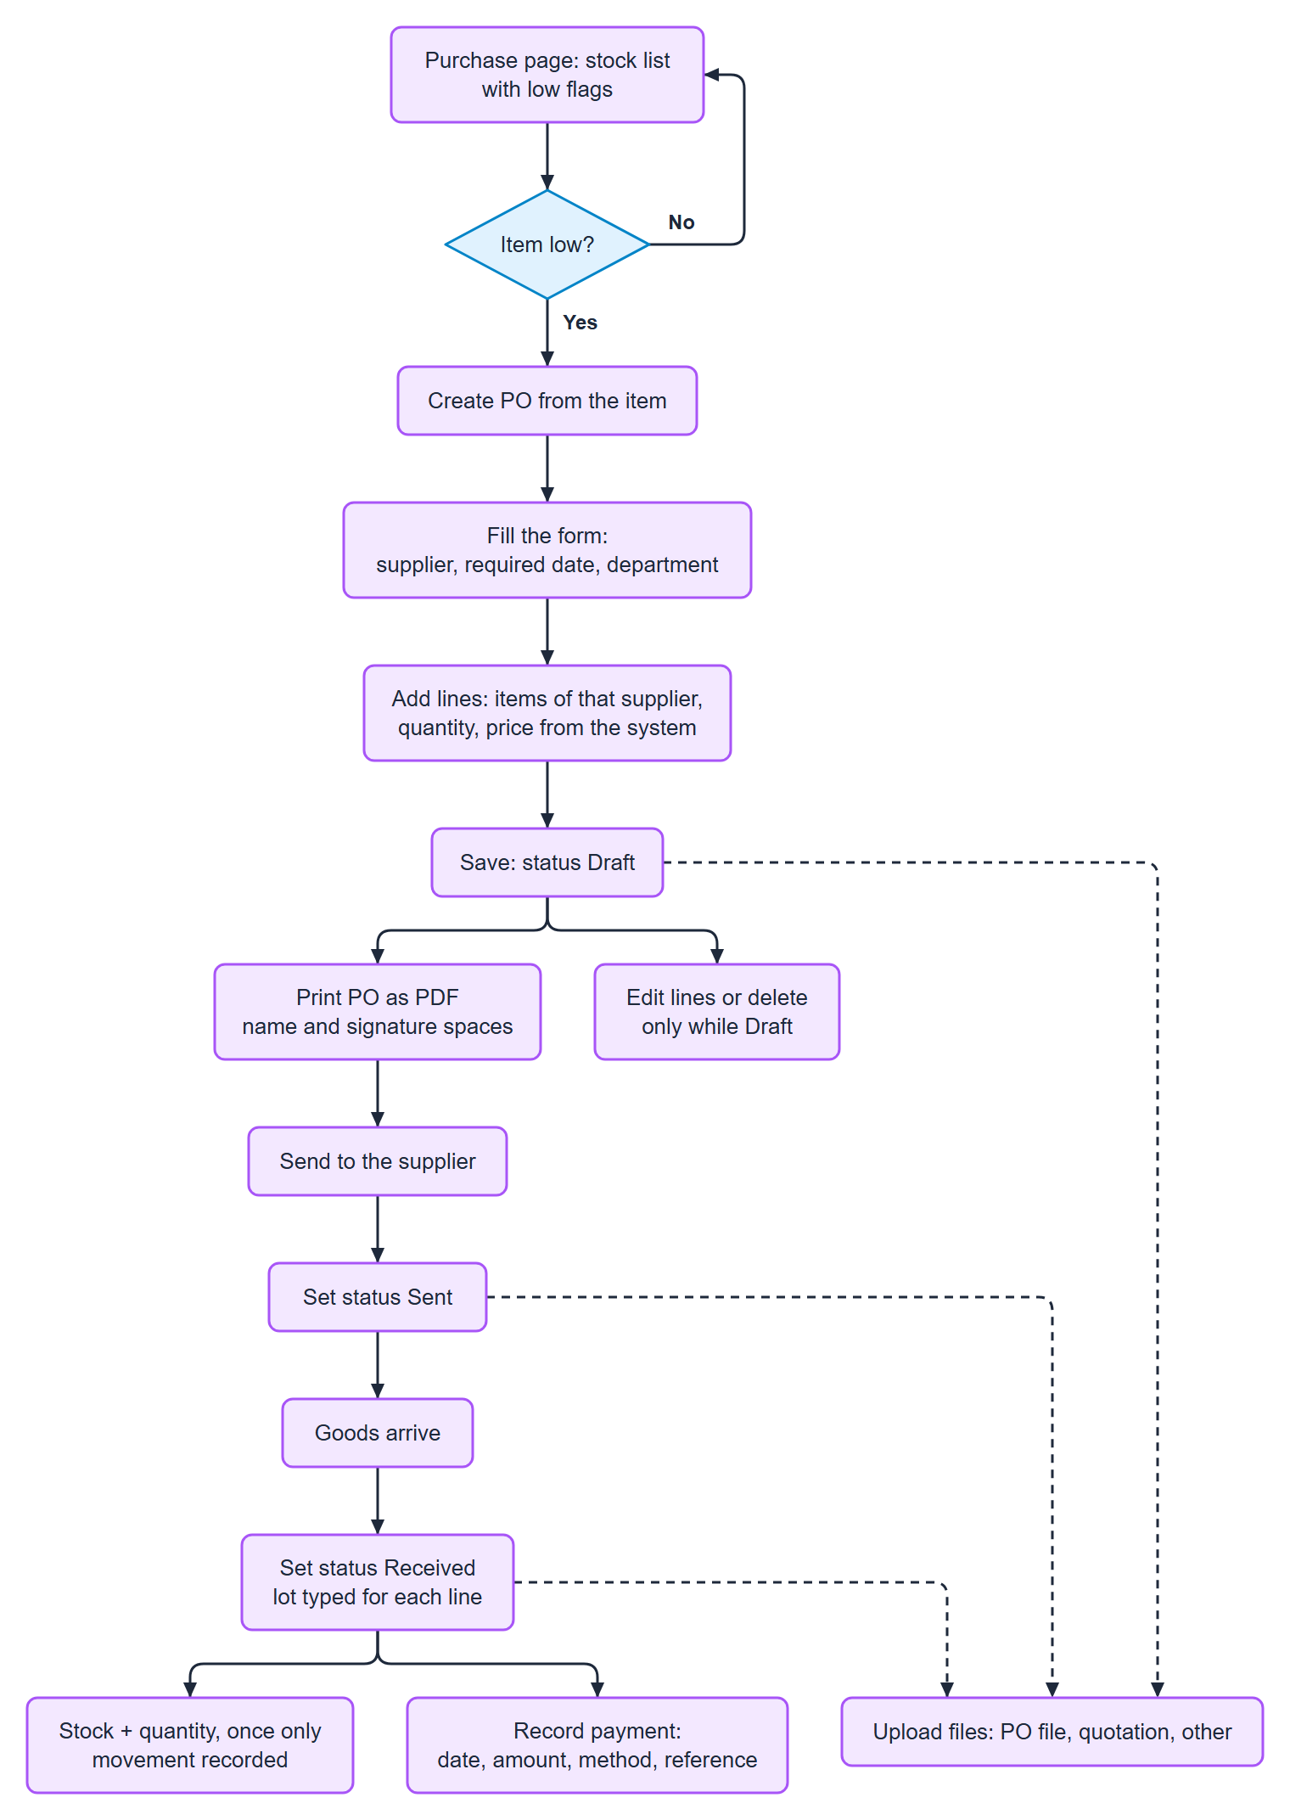
Figure 8. Purchase (Factory Worker and Admin)
Suppliers and their items and prices are kept by the Admin; the Factory Worker can only view them.

Admin
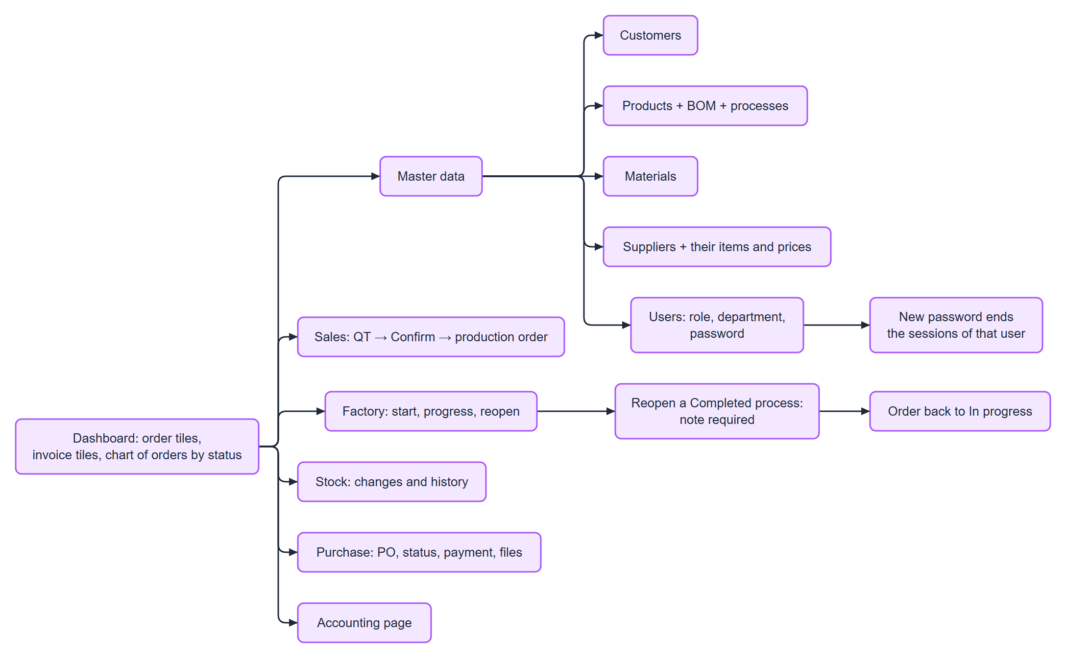
Figure 9. Admin
The Admin can do everything the two Workers can.

Admin: accounting
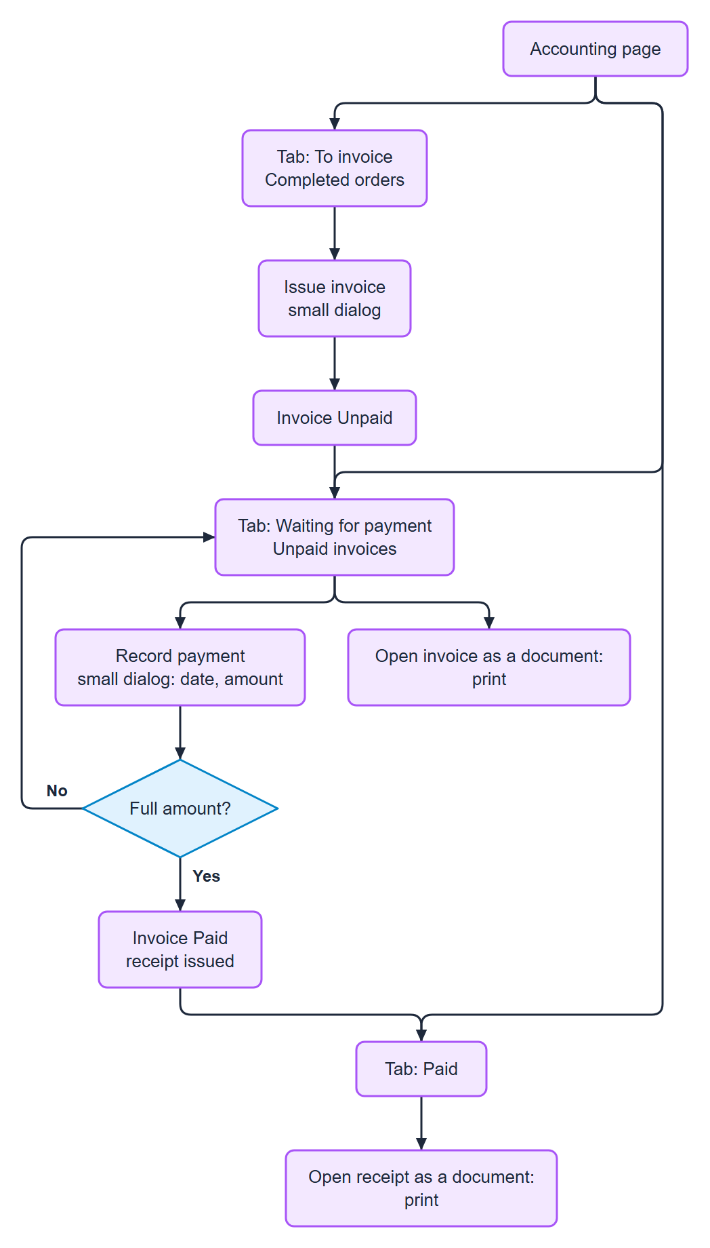
Figure 10. Admin: accounting

Master data
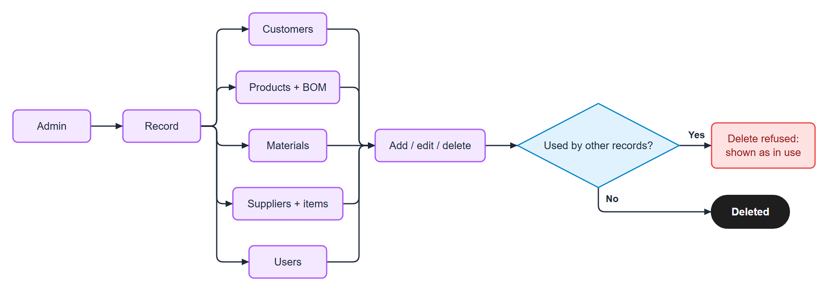
Figure 11. Master data
Sale Worker: view customers and products. Factory Worker: view products and suppliers.

Who can do what
Area | Admin | Sale Worker | Factory Worker
Dashboard | all tiles + chart | order tiles | order tiles
QT: create, print, upload PO, confirm, delete a Draft | yes | yes | no access
Production orders: view | yes | yes | yes
Production orders: add / edit the processes before start | yes | no | yes
Start production, record progress | yes | no | yes
Reopen a Completed process | yes | no | no
Evidence upload (production order) | yes | no | yes
Stock: view and movements | yes | yes | yes
Stock changes by hand | yes | no | yes
Materials: add, edit, delete | yes | no | no
Purchase: PO, status, print, payment, files | yes | no | yes
Suppliers | yes | no | view only
Customers | yes | view only | no
Products | yes | view only | view only
Invoices, receipts | yes | no | no
Users | yes | no | no

Print and upload (any page with files)
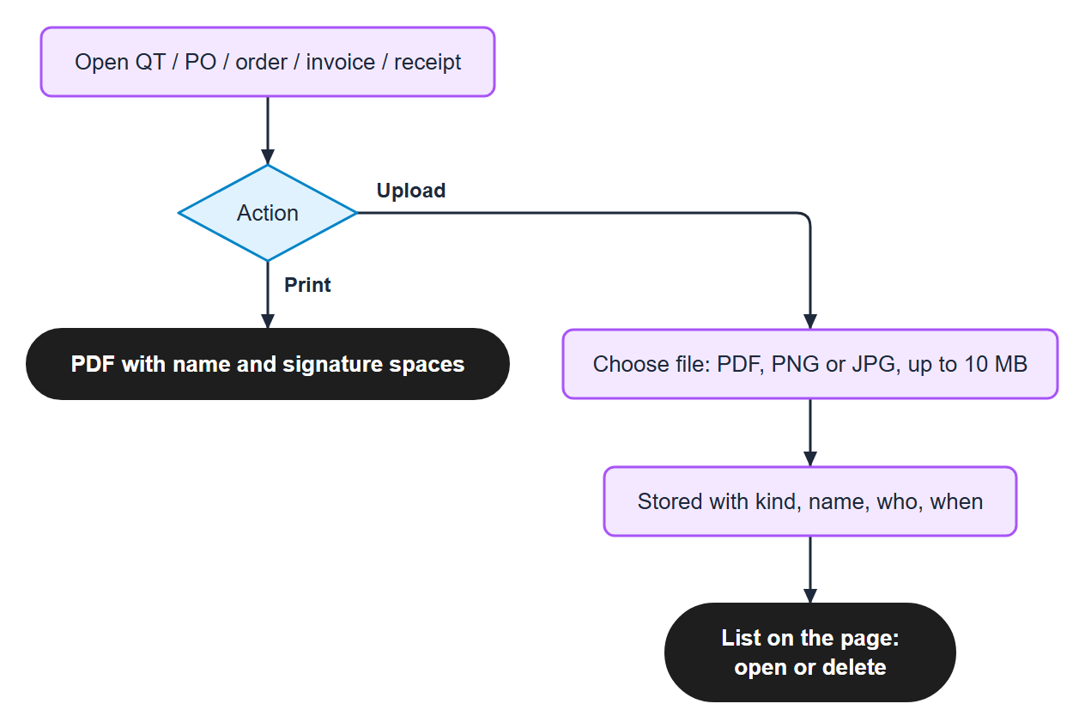
Figure 12. Print and upload (any page with files)
Page | Files
QT | customer PO
Production order | evidence: images and documents (Admin, Factory)
Purchase order | PO file, quotation, other files

Errors a user may see
Message | When | What to do
Invalid credentials | wrong email or password | try again; ask the Admin to reset
403 Forbidden page | a page or action the role may not use | go back; ask the Admin
409 STOCK_SHORT | start production without enough material | purchase or add stock, then start again
Validation error | a required field is missing (QT without customer or line) | fill the field
In use | delete of a record other records use | keep it, or remove the uses first
Session ended | token expired or password changed | sign in again

